# **DataGrid 2 POC – Documentation**

## **Problem:**

The configurations of data grid 2 selected by the user are reversed (change to default state) when page is refreshed by the user.

## **Solution:**

This problem can be tackled by using the data grid 2 configuration attribute and storing it to the DB.

## **Steps to Implement solution:**

* Create an entity as:

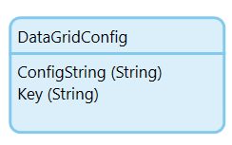   
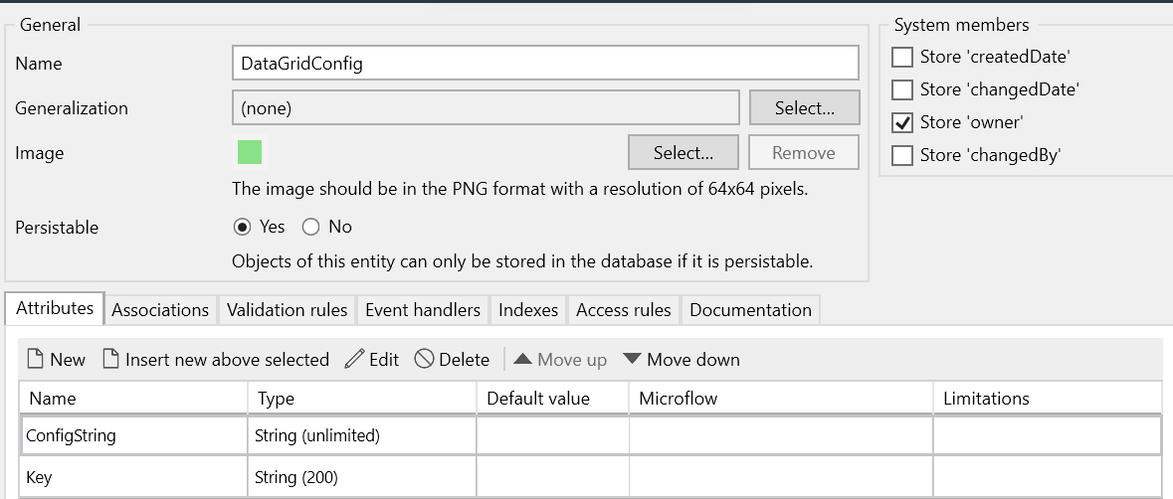  
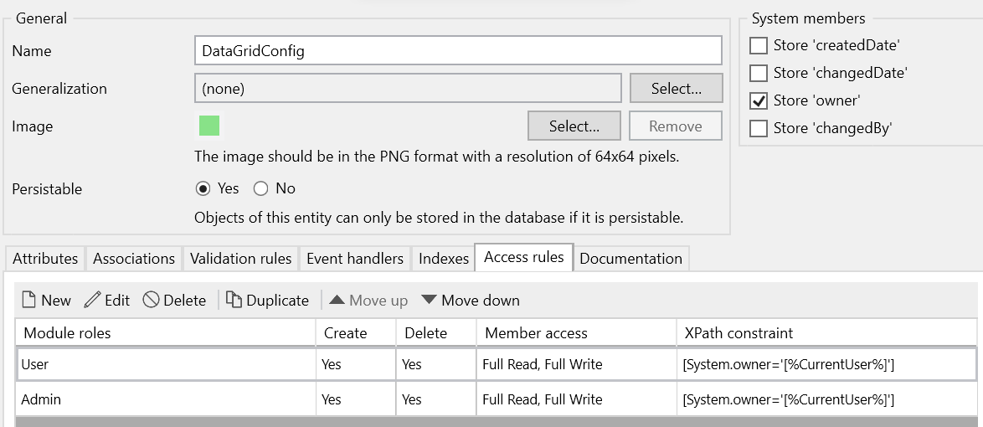

* Place the data grid 2 inside a data view with DS microflow:

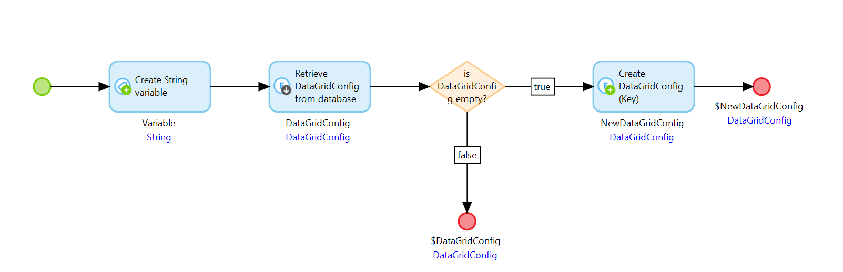  
 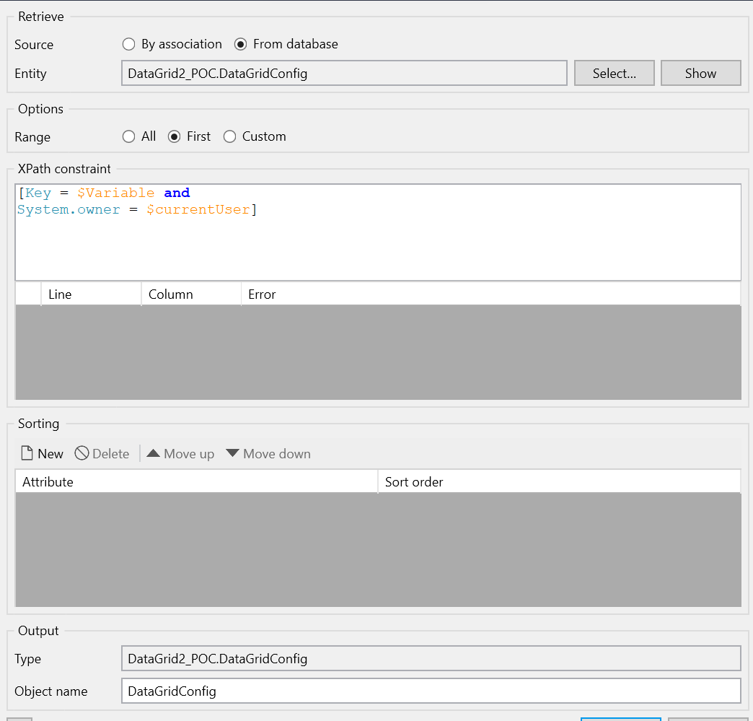

* + Where variable is a unique key.
  + Use variable as key while creating and retrieving DataGridConfig Object.
* Set configuration of data grid 2 under the Personalization tab as:

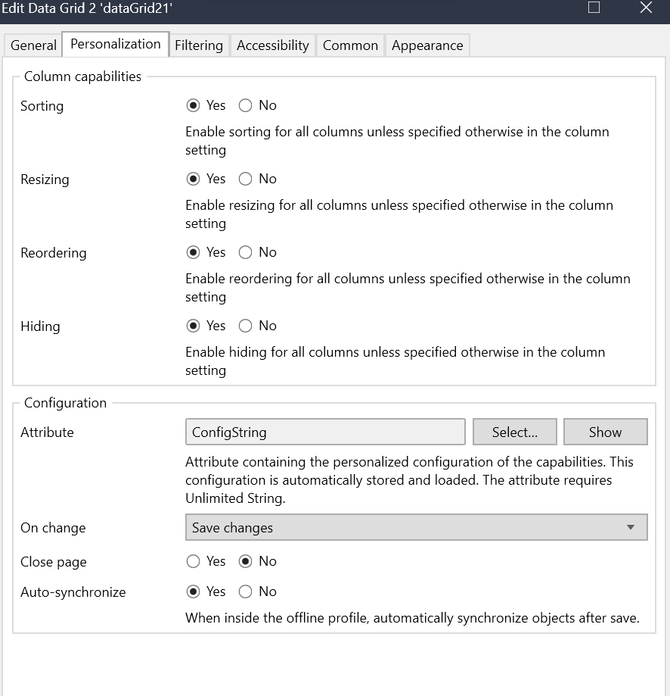

Author:

Shubham Garg

Shraddha Gupta